**Assignment - 7 A Job Ready Bootcamp in C++, DSA and IOT**

Iterative Control Statements (Part - 2)

**1. Write a program to find the Nth term of the Fibonacci series.**

#include<stdio.h>

int main()

{

int previous=0,current=1,next=0,i=0,n;

printf("Enter a number\t");

scanf("%d",&n);

for(i=0; i<n-1; i++)

{

next=previous+current;

previous=current;

current=next;

}

printf("The %dth term of fibonacci seris is %d",n,next);

return 0;

}

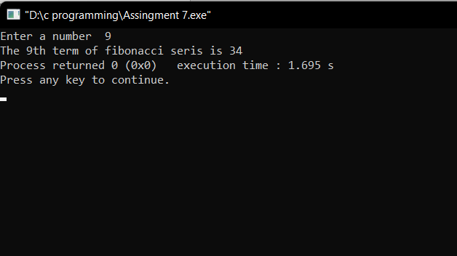

**2. Write a program to print first N terms of Fibonacci series**

#include<stdio.h>

int main()

{

int previous=0,current=1,next=0,i=0,n;

printf("Enter a number\t");

scanf("%d",&n);

printf("The %d terms of fibonacci series are \n1",n);

for(i=0; i<n-1; i++)

{

next=previous+current;

printf("\n%d",next);

previous=current;

current=next;

}

return 0;

}

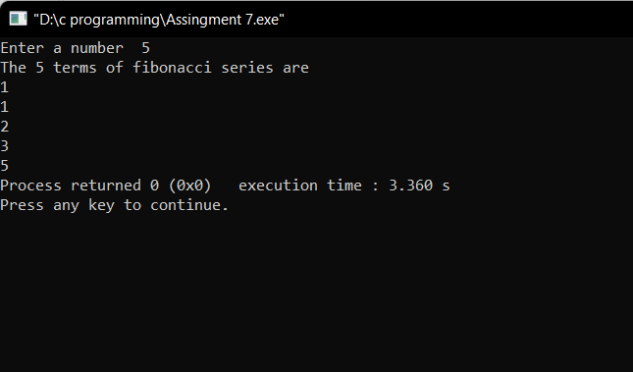

**3. Write a program to check whether a given number is there in the Fibonacci series or not.**

#include<stdio.h>

int main()

{

int previous=0,current=1,next=0,i=0,n;

printf("Enter a number\t");

scanf("%d",&n);

for(i=0; 1; i++)

{

next=previous+current;

previous=current;

current=next;

if(next==n)

{

printf("Number in series");

break;

}

else if(next>n)

{

printf("Number not in series");

break;

}

}

return 0;

}

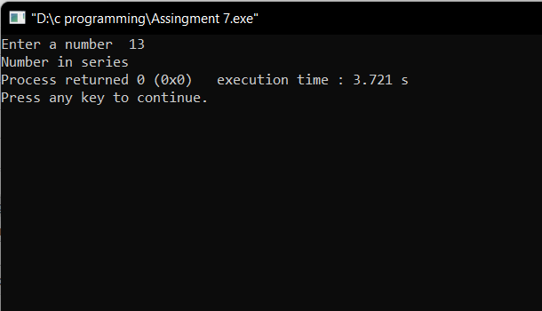

**4. Write a program to calculate HCF of two numbers**

#include<stdio.h>

int main()

{

int a,b,i=1,min,hcf=1;

printf("Enter two numbers ");

scanf("%d%d",&a,&b);

min= a<b?a:b;

for(i=1; i<=min; i++)

{

if( a%i==0 && b%i==0 )

hcf=i;

}

printf("HCF of %d and %d is %d",a,b,hcf);

return 0;

}

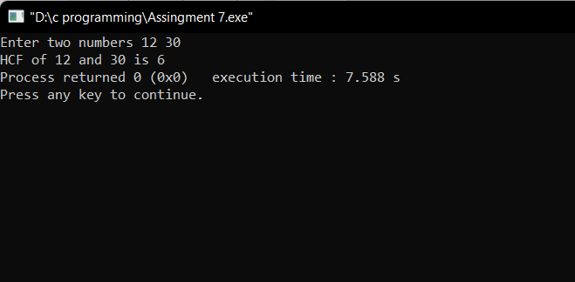

**5. Write a program to check whether two given numbers are co-prime**

**numbers or not**

#include<stdio.h>

int main()

{

int a,b,i=1,min,hcf=1;

printf("Enter two numbers ");

scanf("%d%d",&a,&b);

min= a<b?a:b;

for(i=1; i<=min; i++)

{

if( a%i==0 && b%i==0 )

hcf=i;

}

if(hcf==1)

printf("co-prime");

else

printf("Not co-prime");

return 0;

}

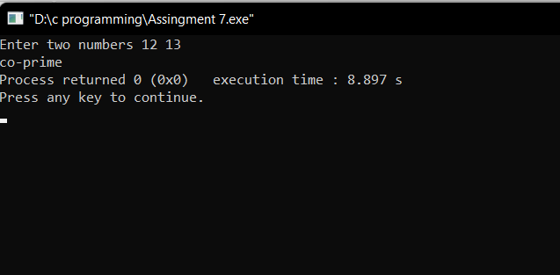

**6. Write a program to print all Prime numbers under 100**

#include <stdio.h>

int main()

{

int i,j,count=0;

for(i=2;i<=100;i++)

{

for(j=1;j<=i;j++)

{

if(i%j==0)

count++;

}

if(count==2)

printf("%d\n",i);

count=0;

}

return 0;

}

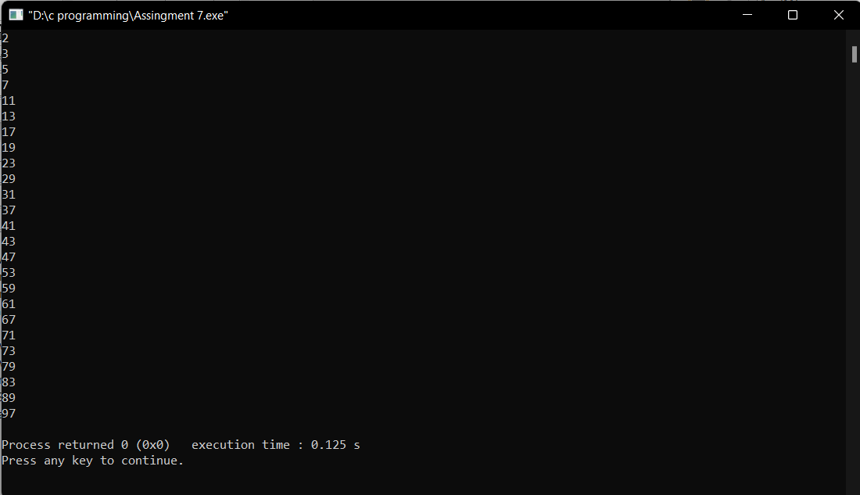

**7. Write a program to print all Prime numbers between two given numbers**

#include <stdio.h>

int main()

{

int num1,num2,j,count=0;

printf("Enter two numbers ");

scanf("%d%d",&num1,&num2);

printf("The prime numbers between %d and %d are:\n",num1,num2);

for(num1;num1<=num2;num1++)

{

for(j=1;j<=num1;j++)

{

if(num1%j==0)

count++;

}

if(count==2)

printf("%d\n",num1);

count=0;

}

return 0;

}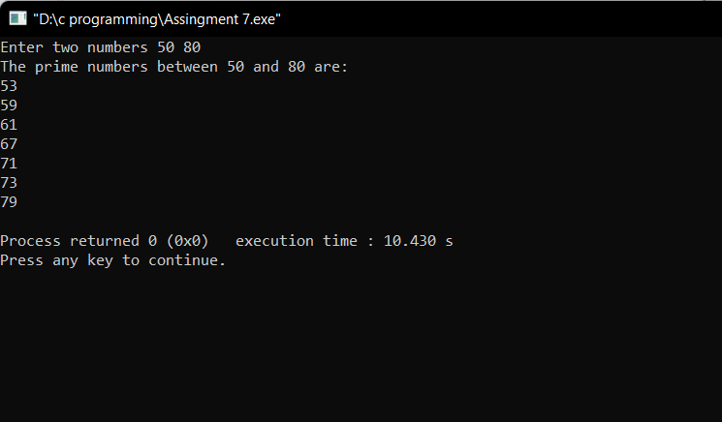

**8. Write a program to find next Prime number of a given number**

#include <stdio.h>

int main()

{

int num1,j,count=0,k=0;

printf("Enter a number ");

scanf("%d",&num1);

printf("The next prime is ");

k=num1+1;

for(k;1;k++)

{

for(j=1;j<=k;j++)

{

if(k%j==0)

count++;

}

if(count==2)

{

printf("%d\n",k);

break;

}

count=0;

}

return 0;

}

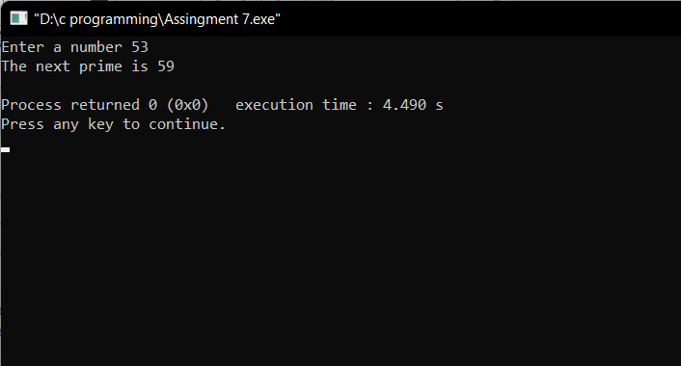

**9. Write a program to check whether a given number is an Armstrong number or not**

#include <stdio.h>

int main()

{

int num,i=0,x,arms=0,num2=0;

printf("Enter a numbers ");

scanf("%d",&num);

num2=num;

for(i=0;num!=0;i++)

{

x=num%10;

num=num/10;

arms+=(x*x*x);

}

if(num2==arms)

printf("Number is Armstrong");

else

printf("Not Armstrong");

return 0;

}

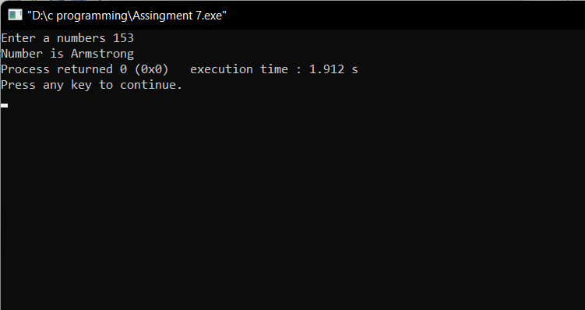

**10. Write a program to print all Armstrong numbers under 1000**

#include <stdio.h>

int main()

{

int num=0,i=1,x=0,s;

printf("Armstrong number under 1000 are\n");

for(i=1;i<=1000;i++)

{

s=0;

for(num=i;num!=0;num=num/10)

{

x=num%10;

s=s+(x*x*x);

}

if(i==s)

printf("%d\n",i);

}

return 0;

}

